Pupil premium strategy statement

This statement details our school’s use of pupil premium (and recovery premium for the 2023 to 2024 academic year) funding to help improve the attainment of our disadvantaged pupils.

It outlines our pupil premium strategy, how we intend to spend the funding in this academic year and the effect that last year’s spending of pupil premium had within our school.

School overview
Detail | Data
School name | Sandhurst Primary School
Number of pupils in school | 156 (Nov 2022)  161 (October 2023)
Proportion (%) of pupil premium eligible pupils | 28% (November 2022)  21% (October 2023)
Academic year/years that our current pupil premium strategy plan covers (3 year plans are recommended) | 2021/2022  2022/2023  2023/2024
Date this statement was published | November 2023
Date on which it will be reviewed | November 2024
Statement authorised by | Amanda Norman, Headteacher
Pupil premium lead | Louise Reeves,  SLT
Governor | Frances Holland
Funding overview
Detail | Amount
Pupil premium funding allocation this academic year | £53,280
Pupil premium funding carried forward from previous years (enter £0 if not applicable) | £0
Out of county PP | £0
PP plus | £0
Total budget for this academic year  If your school is an academy in a trust that pools this funding, state the amount available to your school this academic year | £53,280

Part A: Pupil premium strategy plan

Statement of intent
At Sandhurst Primary School our intention is that all pupils, irrespective of their background or the challenges they face, make good progress and achieve high attainment across all subject areas. The focus of our pupil premium strategy is to support disadvantaged pupils to achieve that goal, including progress for those who are already high attainers.
We will consider the challenges faced by vulnerable pupils, such as those who have a social worker and young carers, as well as those facing increased challenges due to the impact of the coronavirus pandemic. The activities we have outlined in this statement is also intended to support the needs of children, regardless of whether they are disadvantaged or not.
There is no expectation that all Pupil Premium children will receive identical support; some children will need more than others and each child is individual with individual circumstances. The school considers how to allocate pupil premium money on an annual basis following rigorous data analysis and careful consideration of the needs of the children within this group and this is reviewed termly within the pupil progress meetings
Quality First Teaching is at the heart of our approach, with a focus on areas in which disadvantaged pupils require the most support. This is proven to have the greatest impact on closing the disadvantage attainment gap and at the same time will benefit the non-disadvantaged pupils in our school. Implicit in the intended outcomes detailed below, is the intention that non-disadvantaged pupils’ attainment will be sustained and improved alongside progress for their disadvantaged peers.
Our approach will be responsive to common challenges and individual needs, rooted in robust diagnostic assessment, not assumptions about the impact of disadvantage. The approaches we have adopted complement each other to help pupils excel. To ensure they are effective we will:
- ensure disadvantaged pupils are challenged in the work that they’re set
- act early to intervene at the point need is identified
- adopt a whole school approach in which all staff take responsibility for disadvantaged pupils’ outcomes and raise expectations of what they can achieve

Challenges

This details the key challenges to achievement that we have identified among our disadvantaged pupils.
Challenge | Detail of challenge
1 | Wellbeing and Social and Emotional Development:  Our Leuven observations and conversations in school show that a number of our disadvantaged children show lower well-being and involvement compared to our non-disadvantaged children. This has an impact on their mental health and subsequent ability to learn. As part of our quality first teaching approaches all classes are using the self-regulation charts in class, and can indicate worries and problems to staff through the class worry boxes, resulting in class teachers being able to be responsive with support.
2 | Attendance:  From September 2022 to July 2023 the attendance for PP pupils was 92.2% compared to the whole school attendance of 93.5%. Although in Term 6 2023, attendance for PP pupils was 94.4% compared to whole school attendance of 94%.  Our assessments and observations indicate that absenteeism is negatively impacting on disadvantaged pupils’ progress. This impacts on their opportunities for learning, and needs to be addressed in order to support them to become more effective learners.
3 | Assessments:  Assessments show that in KS1 and 2 in reading 19% of PP children are working below age expected levels and in writing 25% and in maths 22%.  In EYFS 29% of PP children are working below age expected levels in reading, writing and maths.  Discussions with younger pupils suggest disadvantaged pupils generally have greater difficulties with phonics than their peers. This negatively impacts their development as readers. Significant knowledge gaps are leading to pupils falling further behind age-related expectations, especially in reading and writing.
4 | Progress:  Some children are making below expected progress in reading, writing and maths, therefore they need to make accelerated progress to be at the level at which they should be working.
5 | Extra-Curricular:  Engagement in after school clubs ensure enrichment of the curriculum and opportunities for pupils to flourish in areas of interest and enjoyment. Some pupils are unable to attend due to financial burdens. This also includes our Upper KS2 residential trip.
6 | Speaking and Listening:  Assessments, observations, and discussions with pupils indicate underdeveloped oral language skills and vocabulary gaps among some disadvantaged pupils. These are evident from EYFS through to KS2 and in general, are more prevalent among our disadvantaged pupils than their peers.

Intended outcomes
This explains the outcomes we are aiming for by the end of our current strategy plan, and how we will measure whether they have been achieved.
Intended outcome | Success criteria
- To achieve and sustain improved wellbeing for all pupils in our school, particularly our disadvantaged pupils. | Sustained high levels of wellbeing from demonstrated by:  - qualitative data from student voice, student and parent surveys and teacher observations (Leuven)  - a significant increase in participation in enrichment activities, particularly among disadvantaged pupils (including attendance of clubs/ trips etc)  - Data will show a decrease in the number of wellbeing concerns raised by parents and teachers. Monitoring will highlight the decreased number of incidents on CPOMS.
- Attendance for PP children and non-PP children to be in-line or better than National Average. | - Less than 4% attendance gap between Pupil Premium and non-Pupil Premium children.  - Attendance of Pupil Premium learners to meet the 96.5% target.  - PP Leads meet regularly with the Attendance Officer and Education Welfare Officer and have a clear plan in place for pupils with low attendance. Staff are aware of difficulties that may impact PP learners and have plans in place to support these children.  - the percentage of all pupils who are persistently absent being below 5% and the figure among disadvantaged pupils being no more than 2% lower than their peers.
- & 4)  Disadvantaged pupils to be working at an expected level in reading and writing at the end of KS2  Closing of gap between disadvantaged and non-disadvantaged in core subjects.  Raising the percentage of disadvantaged pupils achieving greater depth in reading and writing | - Year 1 phonics screening for this academic year will show that the percentage of pupils who pass are inline or above the Kent and National Average pass rate.  - Read, Write Inc termly assessments to show PP children progressing through the scheme at age expected levels. RWI interventions in place to support low attainers.  - Writing, reading and maths outcomes will demonstrate that more than 75% of disadvantaged pupils meet the expected standard.  - A minimum of 5% of disadvantaged children will achieve greater depth across maths, writing and reading
5) To achieve and sustain higher levels of uptake of all extra-curricular clubs and trips for disadvantaged pupils Pupil Premium learners are fully engaged and participating in the school’s rich extra- curricular offer. | - Monitoring of extra-curricular activity attendance to show that all PP children access a minimum of one enrichment activity. Teachers and Activity leads are aware of the need to promote PP attendance and promote/invite/prioritise PP learners. The school will fund extra-curricular clubs or enrichment activities, such as music lessons and the payment of trips/workshops for PP children as necessary.
6) Ensure oral language skills and vocabulary gaps are improved so disadvantaged pupils are developing at the same rate as their peers | - Assessments and observations indicate significantly improved oral language among disadvantaged pupils. This is evident when triangulated with other sources of evidence, including engagement in lessons, book scrutiny and ongoing formative assessment.  - Language and speech link used effectively to identify gaps in oral language skills and vocabulary are targeted where necessary.  - Interventions to support oral language and vocabulary provided for disadvantaged pupils.  - Referrals made to SALT when required for external professional support  - Opportunities provided for language rich enhancements, such as forest school, gardening and after school clubs.

Activity in this academic year
This details how we intend to spend our pupil premium (and recovery premium funding) this academic year to address the challenges listed above.

Teaching (for example, CPD, recruitment and retention)
Budgeted cost: £6300
Activity | Evidence that supports this approach | Challenge number(s) addressed
Embed consistent teaching of the phonics scheme Read Write Inc.  Provide bespoke training for new staff unfamiliar with this scheme.  Introduce the use of the ‘Fresh Start’ scheme for KS2 pupils.  Staff training | Phonics approaches have a strong evidence base that indicates a positive impact on the accuracy of word reading (though not necessarily comprehension), particularly for disadvantaged pupils:  Phonics | EEF (educationendowmentfoundation.org.uk)  Mission - Ruth Miskin Phonics Training  Read Write Inc. Phonics and Fresh Start | EEF (educationendowmentfoundation.org.uk) | 3, 4, 6
Nessy provision and implementation | Assessment resources and tools for dyslexia  What is Dyslexia? | Nessy | 3, 4, 6
Educational Psychologist SLA  (School based review X3 per year) | To provide staff with high quality professional support, especially on a 1:1 when an identified child needs further support.  8 Benefits of Educational Psychology to the Teacher - Classplus Growth Blog (classplusapp.com) | 1, 3, 4
Purchase of standardised diagnostic assessments.  (Implemented 3X per year)  Training for staff to ensure assessments are interpreted and administered correctly. | Standardised tests can provide reliable insights into the specific strengths and weaknesses of each pupil to help ensure they receive the correct additional support through interventions or teacher instruction:  Standardised tests | Assessing and Monitoring Pupil Progress | Education Endowment Foundation | EEF  Using CAT4 in primary schools - GL Assessment (gl-assessment.co.uk)  NFER Tests - NFER | 1, 2, 3, 4
Embedding, assessing for and supporting speaking and listening activities across the school curriculum. These can support pupils to articulate key ideas, consolidate understanding and extend vocabulary.  We will purchase resources and fund ongoing teacher training and release time. | There is a strong evidence base that suggests oral language interventions, including dialogic activities such as high-quality classroom discussion, are inexpensive to implement with high impacts on reading:  Oral language interventions | Toolkit Strand | Education Endowment Foundation | EEF | 1
Improve the quality of social and emotional (SEL) learning.  SEL approaches will be embedded into routine educational practices and supported by professional development and training for staff. | There is extensive evidence associating childhood social and emotional skills with improved outcomes at school and in later life (e.g., improved academic performance, attitudes, behaviour and relationships with peers):  EEF_Social_and_Emotional_Learning.pdf(educationendowmentfoundation.org.uk)  Metacognition and self-regulation | EEF (educationendowmentfoundation.org.uk) | 1, 6
Targeted academic support (for example, tutoring, one-to-one support structured interventions)
Budgeted cost: £32,000
Activity | Evidence that supports this approach | Challenge number(s) addressed
Accelerated reader training, provision and implementation | The Education Endowment Foundation recently ran a project investigating the effectiveness of Accelerated Reader, which found that it appears to be effective for weaker readers as a catch-up intervention at the start of secondary school.  Accelerated Reader | 3, 4
Barrington Stokes Reading Intervention books | Targeted 1:1 reading intervention supports specific children to improve reading and language  Dyslexic and Reluctant Readers - Barrington Stoke | 3, 4, 6
Laptops (part funded) | For use for online learning as well as in- class learning opportunities.  Remote Learning:
Forest school (partly funded for PP and vulnerable pupils). | Forestry commission evaluation and evidence of impact on learning - resilience, problem solving and self confidence  A marvellous opportunity for children to learn | 1, 2, 4, 5, 6
Nessy provision and implementation | Assessment resources and tools for dyslexia  What is Dyslexia? | Nessy | 3, 4, 6
Purchase of Speech and Language Link programmes to improve listening, narrative and vocabulary skills for disadvantaged pupils who have relatively low spoken language skills. | Oral language interventions can have a positive impact on pupils’ language skills. Approaches that focus on speaking, listening and a combination of the two show positive impacts on attainment:  Oral language interventions | EEF (educationendowmentfoundation.org.uk)  Speech and Language Link Packages Brochure | 1, 4
Additional phonics sessions targeted at disadvantaged pupils who require further phonics support. This will be delivered through BRP and RWI 1:1 tuition. For upper KS2 the use of the Read, Write inc Fresh Start intervention. | Phonics approaches have a strong evidence base indicating a positive impact on pupils, particularly from disadvantaged backgrounds. Targeted phonics interventions have been shown to be more effective when delivered as regular sessions over a period up to 12 weeks:  Phonics | Toolkit Strand | Education Endowment Foundation | EEF  Read Write Inc. One-to-one Phonics Kit | Tried and Tested | Teach Primary  Read Write Inc. Fresh Start | Reading intervention | OUP | 2
Wider strategies (for example, related to attendance, behaviour, wellbeing)
Budgeted cost: £15,080
Activity | Evidence that supports this approach | Challenge number(s) addressed
Clubs (extra-curricular activities) | PHYSICAL & MENTAL HEALTH BENEFITS OF AFTER SCHOOL CLUBS - Aspire to Greatness
Play therapist | Evidence of results at Ethical Framework | 1,2, 4, 5, 6
Zones of regulation | Research & Evidence Base - THE ZONES OF REGULATION: A SOCIAL EMOTIONAL LEARNING PATHWAY TO REGULATION  The Benefits of Participation in After School Activities (schoolspecialty.com) | 1, 2, 6
Drawing and talking training and intervention | Self regulation and understanding of self leading to +7 months of academic progress EEF  Drawing & Talking Home - Drawing & Talking (drawingandtalking.com)  Education Endowment Foundation | EEF | 1,3, 4, 5, 6
School, pet Guinea pig and chickens (supplies etc) | Benefits of Classroom Animals | Education Grants (petsintheclassroom.org) | - 2, 5, 6
Parental engagement - coffee mornings | Informal support and information for those disadvantaged families in a non- invasive way.  Parental engagement | EEF (educationendowmentfoundation.org.uk) | 1 & 2
Extra-curricular opportunities including residentials in Y6 and day trips for other year groups. | Evidence of social and emotional skills leading to improved outcomes at school  Social and emotional learning | EEF | 1, 2, 5, 6
Breakfast club | Breakfast in Schools: Healthy & Nutritious (eatright.org) | 1, 2, 4, 5, 6
Fegan’s | Fegans - Counselling Children, Supporting Parents | 1, 2, 5, 6
Embedding principles of good practice set out in the DfE’s Improving School Attendance advice.  This will involve training and release time for staff to develop and implement new procedures and appointing attendance/support officers to improve attendance. | The DfE guidance has been informed by engagement with schools that have significantly reduced levels of absence and persistent absence. | 1, 2
New school uniform | Budget for pupils to receive a funded school jumper/ cardigan and tie in term 1 2023 as we transition to new and updated school uniform.
Contingency fund for acute issues. | Based on our experiences and those of similar schools to ours, we have identified a need to set a small amount of funding aside to respond quickly to needs that have not yet been identified such as a child attending a school trip or the purchase of school uniform. | All

Total budgeted cost: £53,280

Part B: Review of outcomes in the previous academic year

Pupil premium strategy outcomes
This details the impact that our pupil premium activity had on pupils in the 2022 to 2023 academic year.
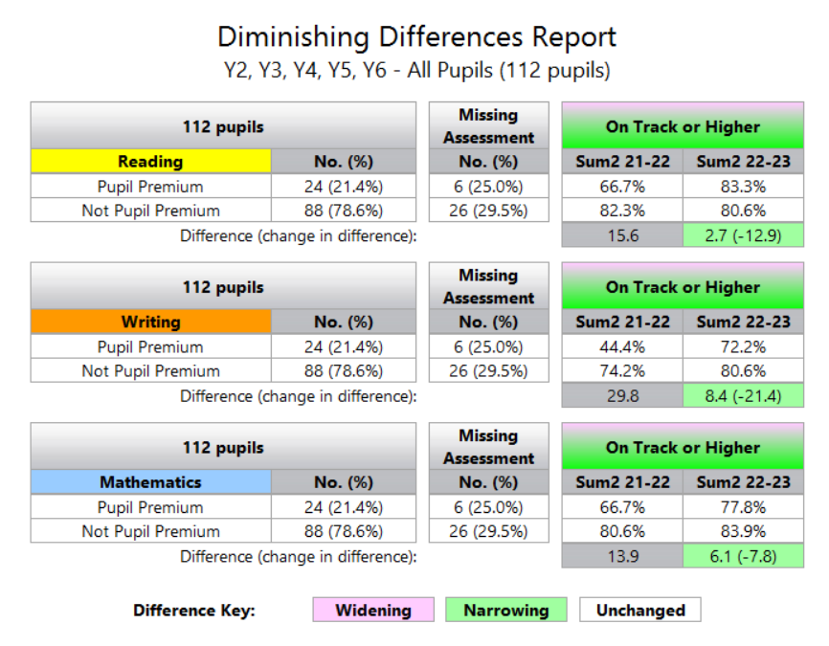
The diminishing differences report highlights that in Y2 to 6, since Summer 2022 to Summer 2023, the gap between PP and Non-PP children has narrowed in Reading, Writing and Maths.
NB this report shows pupils in current year groups (Autumn 2023) so each year group would be in the previous year- ie Y6 is showing Y5 data from Autumn 2022- Summer 2023.

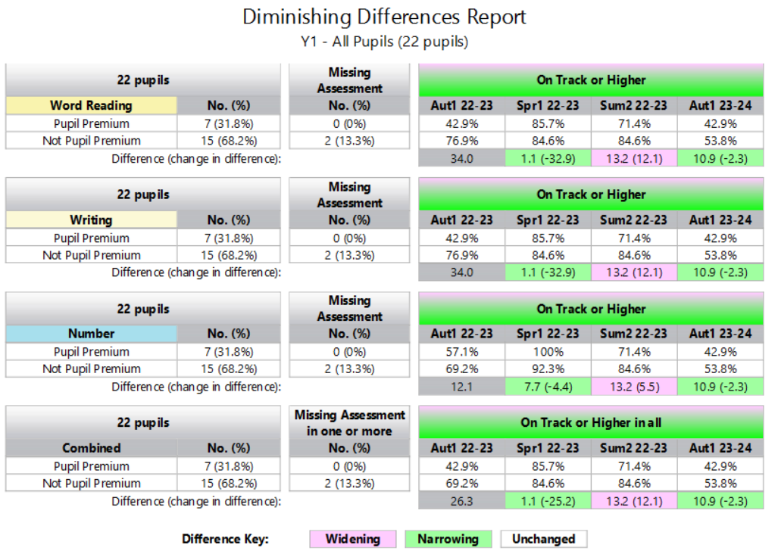
This data shows the end of EYFS exit data (They are currently Y1 Aut 2023) The gap between non-PP and PP pupils had widened in Summer 3 2023- however, 71.9% of PP children were on track or higher.
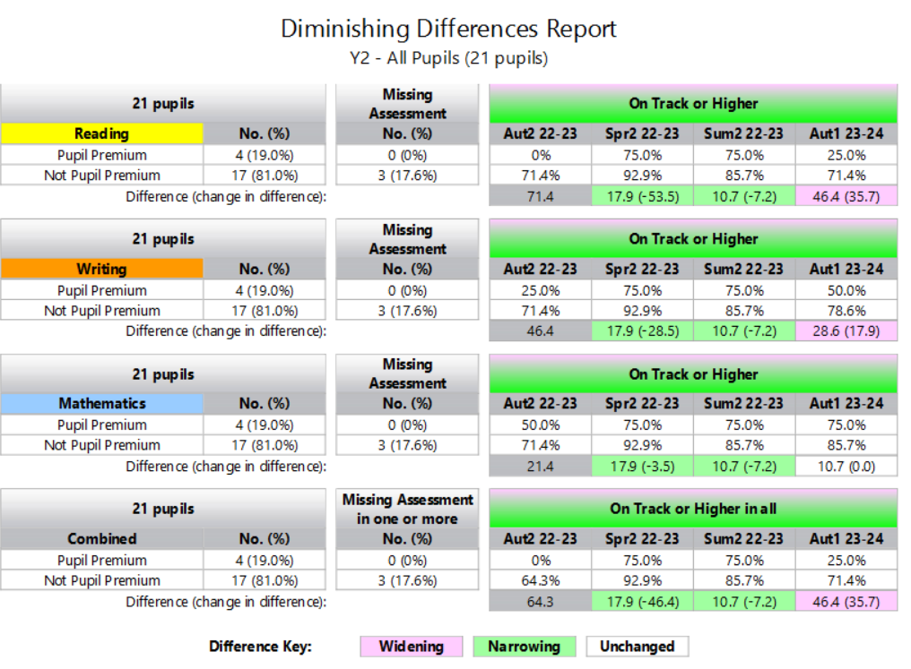
This data shows the end of Year 1 exit data (They are currently Y2 Aut 2023) The gap between non PP and PP pupils had narrowed in Summer 3 2023- 75% of PP children were on track or higher.

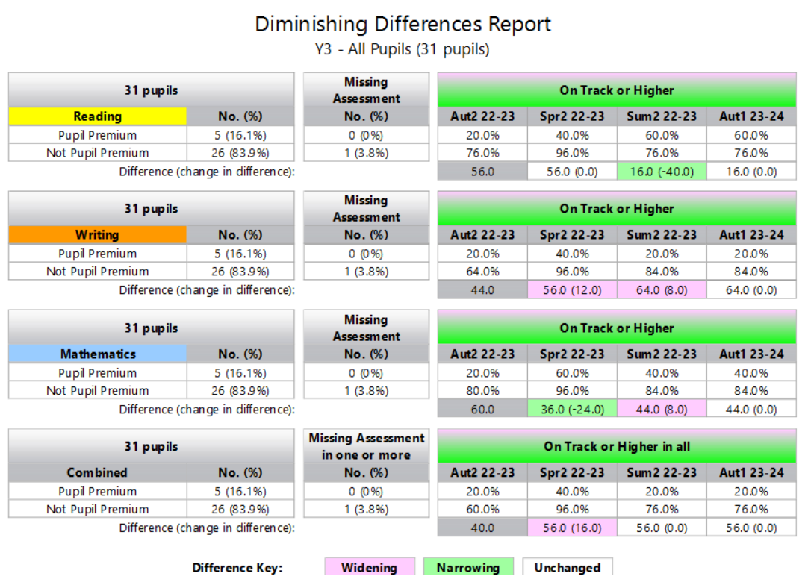
This data shows the end of Year 2 exit data (They are currently Y3 Aut 2023) The gap between non PP and PP pupils had narrowed in Reading in Summer 3 2023- 60% of PP children were on track or higher.
20% of PP were on track in writing at the end of Y2 2023, and 40% in Maths- this resulted in a combined calculation of 20% of PP children on track at the end of Y2 2023.
THIS YEAR GROUP WILL BE A FOCUS AUT 2023-24. (Y3 Sept 2023)

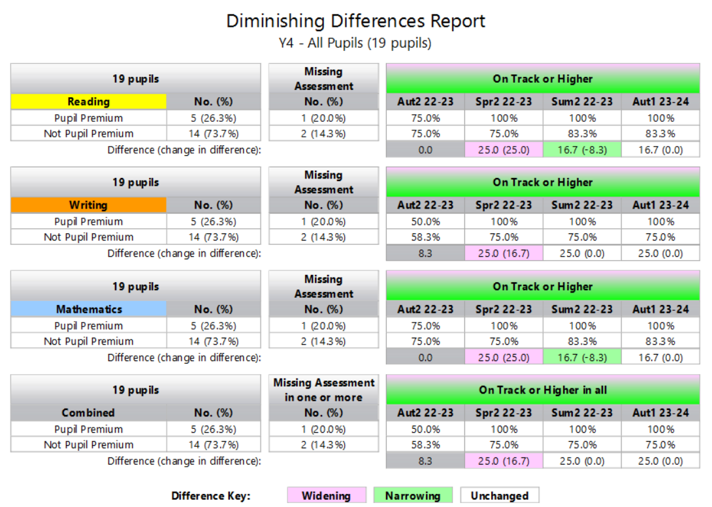 This data shows the end of Year 3 exit data (They are currently Y4 Aut 2023) The gap between non-PP and PP pupils had narrowed in Reading and Maths by Summer 3 2023- 100% of PP children were on track or higher. This was also the case in Writing- although the difference between PP and non-PP had remained the same- there was 100% of PP children on track or higher.

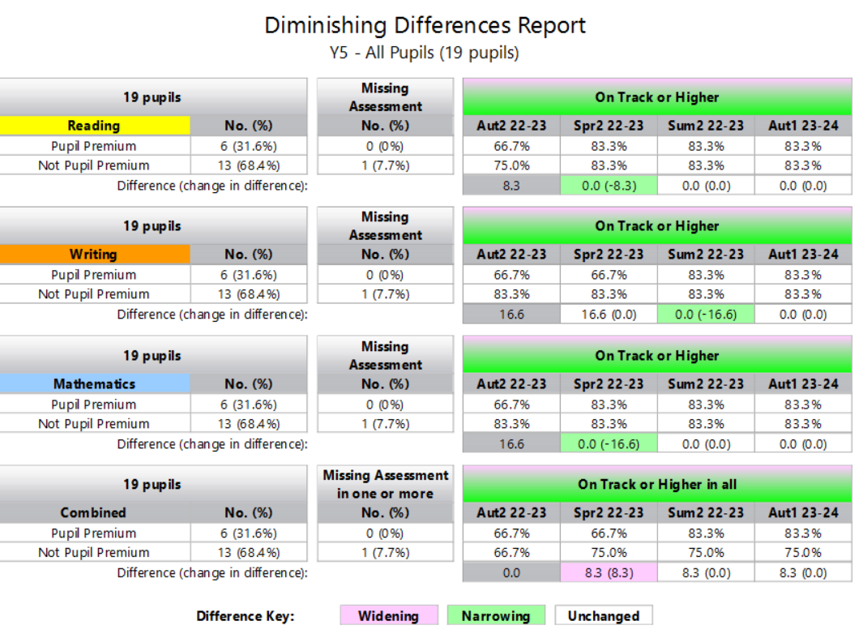
This data shows the end of Year 4 exit data (They are currently Y5 Aut 2023) The gap between non PP and PP pupils had narrowed in Writing in Summer 3 2023- and remained the same in Reading and Maths, resulting in 83.3% of PP pupils on track or higher in Summer 2 2023.
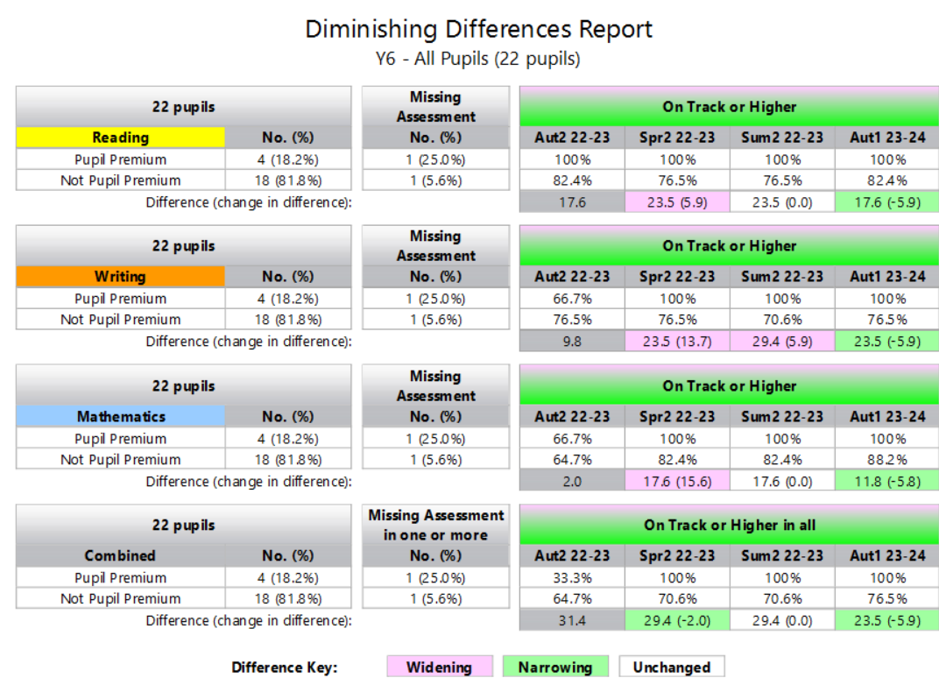
Separating the PP and non-PP enabled us to track the journey of our vulnerable children. The ‘diminishing differences report’ highlights the following:
This data shows the end of Year 5 exit data (They are currently Y6 Aut 2023) The gap between non-PP and PP pupils had widened in Writing in Summer 3 2023- Although 100% of PP children were on track or higher. This was also the case in Reading and Maths- 100% of PP children on track.

Externally provided programmes
Programme | Provider
Nessy | Nessy,com
Speech and Language Link
Sumdog | Sumdog
Big Cat Reading scheme | Collins
Barrington Stokes books | Every child can be a reader - Barrington Stoke
Accelerated Reader | Accelerated Reader
Read, Write Inc | Ruth Miskin
Play therapy | Leslie Wardorp.
Forest school | Wild detectives
Fegan’s | Fegans - Counselling Children, Supporting Parents
Extra-curricular clubs | Dates, Times and Clubs | Sandhurst Primary School

Service pupil premium funding (optional)
Measure | Details
How did you spend your service pupil premium allocation last academic year? | N/A
What was the impact of that spending on service pupil premium eligible pupils? | N/A

Further information (optional)
We class Vulnerable pupils as:
- Those looked after or previously looked after
- those who have a social worker
- those with a CAF/Early Help
- those with a parent/carer in the armed forces
- children classed as a young carer
- children recorded as Ever 6 FSM
- children with no recourse to public funds
- children of offenders
- EAL children
- children with SEN/D Common identified barriers to learning for disadvantaged pupils may include:
- speech, language and communication needs
- challenges for parents supporting children at home
- low self-esteem and/or anxiety
- children or family members with SEMH
- lower attendance or punctuality
There may also be complex family situations that prevent children from flourishing. The challenges are varied and there is no “one size fits all” plan for support.
Additional activity: Our pupil premium strategy will be supplemented by additional activity that is not being funded by pupil premium or recovery premium. That will include:
- embedding more effective practice around feedback. EEF evidence demonstrates this has significant benefits for pupils, particularly disadvantaged pupils.
- utilising a DfE grant to train a senior mental health lead. The training we have selected will focus on the training needs identified through the online tool: to develop our understanding of our pupils’ needs, give pupils a voice in how we address wellbeing, and support more effective collaboration with parents. The approaches we have adopted complement each other to help pupils excel.
To ensure are strategies are effective we will:
- ensure disadvantaged pupils are challenged in the work that they’re set

- act early to intervene at the point need is identified adopt a whole school approach in which all staff take responsibility for disadvantaged pupils’ outcomes and raise expectations of what they can achieve
- offering a wide range of high-quality extracurricular activities to boost wellbeing, behaviour, attendance, and aspiration. Activities will focus on building life skills such as confidence, resilience, and socialising. Disadvantaged pupils will be encouraged and supported to participate.
We have put a robust evaluation framework in place for the duration of our three-year plan and will adjust our plan over time to secure better outcomes for pupils.

